CSA1509-Cloud computing and Big Data Analytics
Name : P Preethi
Reg.no: 192521178

EXP 15 : Create a Snapshot of a VM and Test it by loading the Previous
Version/Cloned VM
Aim:
To Create a Snapshot of a VM and Test it by loading the Previous
Version/Cloned VM.
Steps:
- Download VMware software and install it as Type-2 Hypervisor.
- Download Ubuntu or tiny os as ISO image file.
- In VMware workstation Create new VM
- Do the configuration based on given conditions.
- Create VM
- Go to VM Click on SnapshotTake snapshot.
- We can create n number of Snapshots and can be view through snapshot Manager.
- Launch the VM.

Implementation:
- Download and open VMware software.
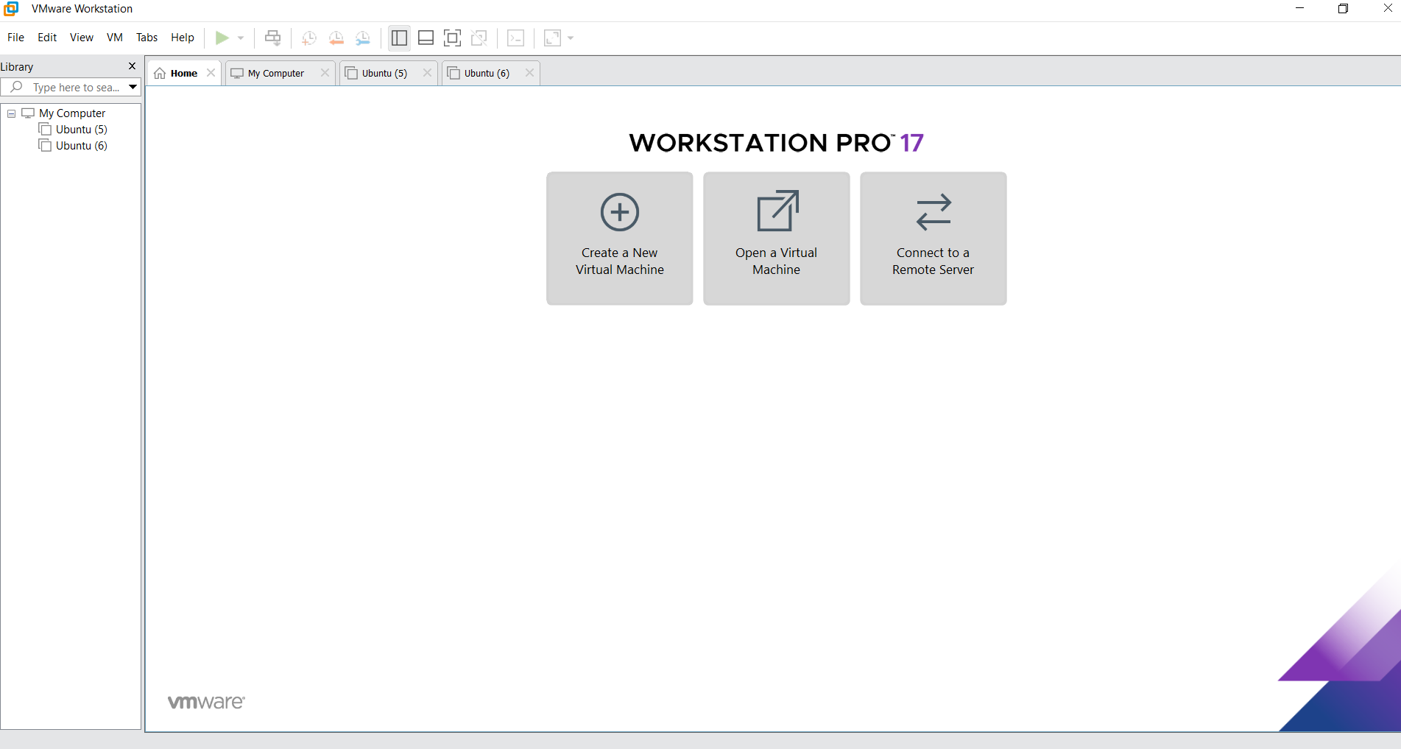
2.Create a new VM

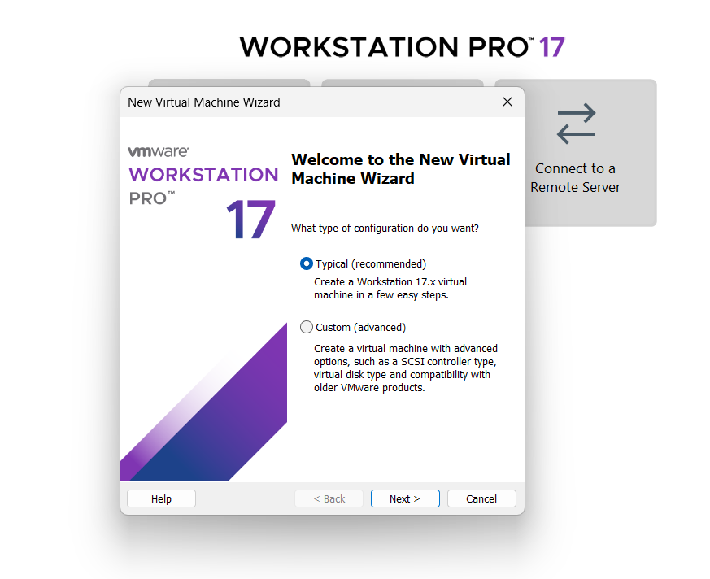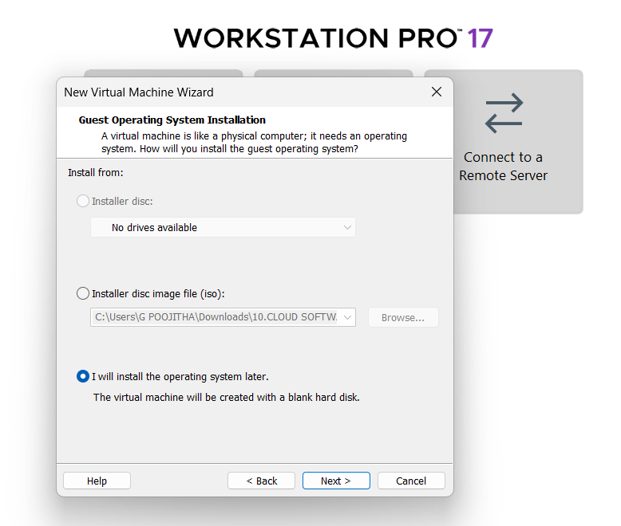
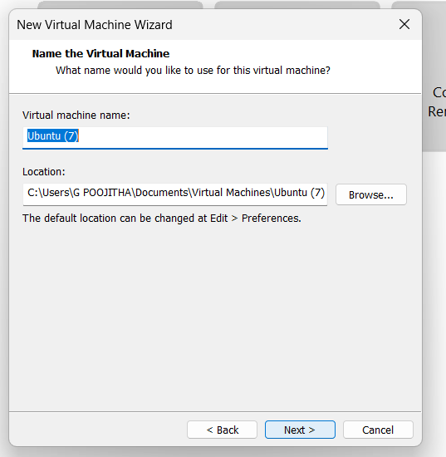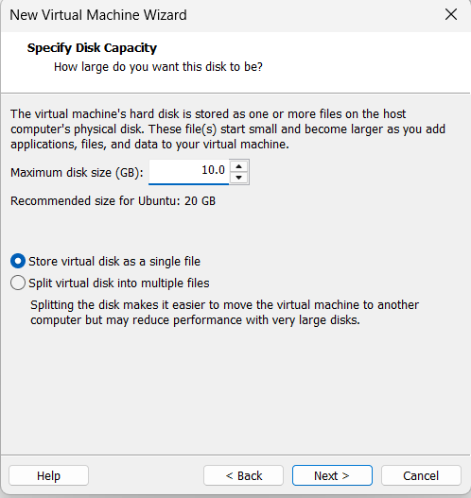
Name it anythingclick on nextAdjust the size of disk change the option to first and then click on next.
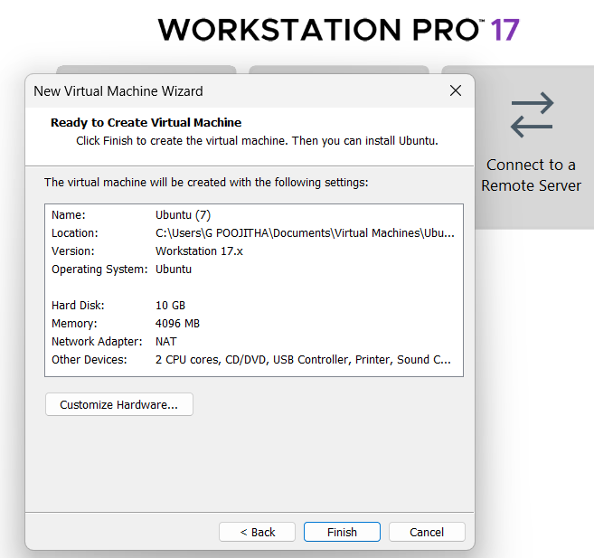 Click on Finish to Launch .
3.VM is created
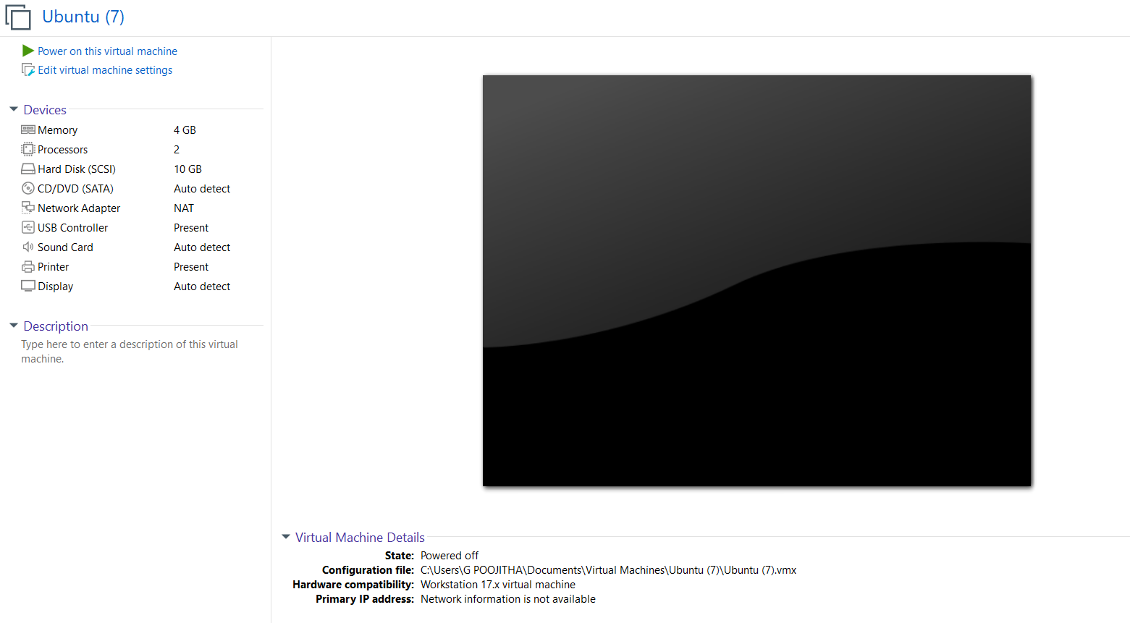
4. Creating Snapshot
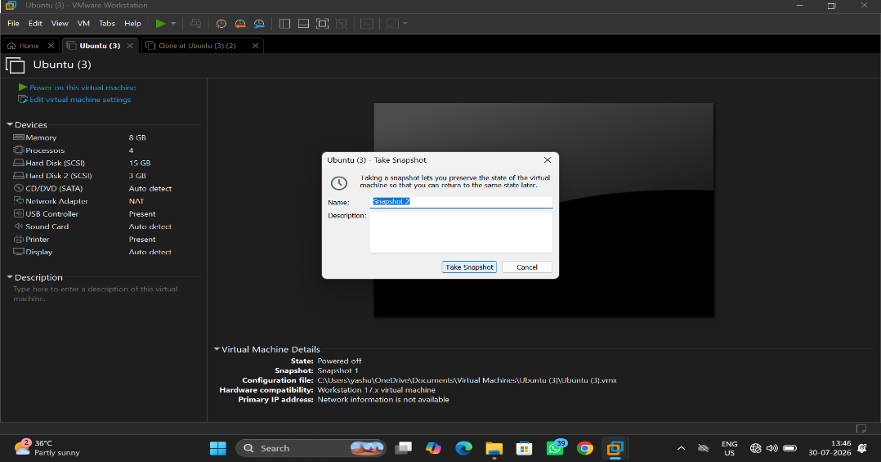
5. View Snapshot
